Available online at website: https://jurnal.iaii.or.id/index.php/RESTI

|  |  |  |
| --- | --- | --- |
| logok.png | JURNAL RESTI  (Rekayasa Sistem dan Teknologi Informasi) | |
| Vol. 9 No. 3 (2025) 494 - 506 | e-ISSN: 2580-0760 |

UDAWA Gadadar: Agent-based Cyber-physical System for Universal Small-scale Horticulture Greenhouse Management System

I Wayan Aditya Suranata1*, Ketut Elly Sutrisni2, I Made Surya Adi Putra3

1Information Technologi Department, Faculty of Engineering and Informatics, Universitas Pendidikan Nasional, Bali, Indonesia

2Business Management Department, Faculty of Economics and Business, Universitas Pendidikan Nasional, Bali, Indonesia

3Kelompok Pemuda Tani Bali, Bali, Indonesia

1aditya@undiknas.ac.id

# Abstract

# *Digitalization in agriculture is becoming increasingly important for improving efficiency and sustainability, but small-scale farmers often face difficulties in adopting digital technologies because of various constraints. This study proposes an open-source intelligent system platform called UDAWA (Universal Digital Agriculture Workflow Assistant) to assist small-scale farmers in digitizing greenhouse management processes. The first variant of this platform, UDAWA Gadadar, was designed as a cyber-physical agent to control and monitor greenhouse instruments. UDAWA Gadadar was built using a 5C architecture approach and farmer-centric design thinking, utilizing an ESP32 microcontroller and a power sensor module to ensure performance and energy efficiency. The UDAWA Gadadar prototype was tested in a small-scale greenhouse with promising results, with an average remaining memory of 175 KB in the non-SSL mode and 122 KB in the SSL mode. Cost analysis indicates that this platform is relatively affordable for small-scale farmers, with a total component cost of USD 33.7 per unit. A decision matrix analysis involving five different greenhouse models in Pancasari Village, Buleleng Regency, Bali, showed that UDAWA Gadadar has high relevance and potential for adoption, particularly in models GH3 and GH5, with compatibility scores of 0.27. This study contributes to the development of appropriate and accessible digitalization solutions for small-scale agriculture, with future work focusing on developing other physical agent variants and a digital twin for enhanced cultivation simulations.*

**Keywords**: digitalization of agriculture; small-scale farmers; greenhouses; intelligent systems; open-source

*How to Cite:* I. W. A. Suranata, Ketut Elly Sutrisni, and I Made Surya Adi Putra, “UDAWA Gadadar: Agent-based Cyber-physical System for Universal Small-scale Horticulture Greenhouse Management System”, *J. RESTI (Rekayasa Sist. Teknol. Inf.)*, vol. 9, no. 3, pp. 494 - 506, Jun. 2025

*Permalink/*DOI: <https://doi.org/10.29207/resti.v9i3.6267>

|  |  |
| --- | --- |
| *Received*: December 29, 2024  *Accepted*: May 31, 2025  *Available Online*: June 18, 2025 | *This is an open-access article under the* [*CC BY 4.0 License*](https://creativecommons.org/licenses/by/4.0/)  *Published by* [*Ikatan Ahli Informatika Indonesia*](https://www.iaii.or.id/) |

1. **Introduction**

By 2050, the world population is projected to reach 9 billion people [1], [2]. This large population puts significant pressure on food production systems [3], emphasizing the importance of efficient and sustainable agricultural practices [4]. The global industrial-scale food production system has begun a transition towards greater efficiency and sustainability, including the implementation of Good Agricultural Practices (GAP) [5]. In practice, GAP involves the application of precision agriculture and smart farming technologies to enhance farming processes [6]-[8]. Precision agriculture refers to the application of precision in farming processes according to specific conditions and needs, such as the use of variable rate technology to optimize resource expenditure [9]. Smart farming enables farmers to make data-driven decisions and automate farm management actions [2], [10]. However, the adoption of GAP supported by digital technology is not readily accessible to all farmers. The high cost of technology investment, farmers' lack of understanding of digital technology, and concerns about vendor lock-in, which forces farmers to rely on specific vendors, hinder the adoption of digital technology, particularly among small-scale farmers [11].

Small-scale farmers play a vital role in maintaining the social and economic stability of lower-middle-class communities [2]. The importance of small-scale farmers in maintaining social and economic stability was evident during the COVID-19 pandemic [12], [13], [14]. Small-scale farmers proved capable of stimulating the local economy and providing a supply of fresh food for the community [15], [16]. The crucial role of small-scale farmers in promoting an efficient and sustainable food supply system underscores the urgency of addressing the challenges of implementing digital agricultural technology within the context of small-scale farming. A major challenge faced by small-scale farmers is low productivity due to their limitations in optimizing water, energy, and fertilizer resources [17]. To optimize resources, small-scale farmers are beginning to adopt greenhouse farming methods [18], [19]. Greenhouse cultivation has been shown to provide income for farmers and improve the quality of yields compared to conventional open-field methods [20].

Although greenhouse farming methods are superior to open-field farming methods, small-scale farmers have problems managing their greenhouses [21]-[23]. Greenhouse farming methods generally involve hydroponic techniques, which rely on nutrient-rich mineral water solutions that can be absorbed directly by plant roots [24]. Various hydroponic techniques for certain commodity types require special attention for optimal plant growth [24], [25]. The levels of dissolved minerals must be adjusted to the plant phase (vegetative and generative), environmental conditions, including temperature, humidity, and lighting. In addition to managing fertigation (fertilization and irrigation), farmers must also protect their greenhouses from pest attacks [26]-[28]. Although greenhouses provide protection against insects, non-ideal and routinely uncontrolled conditions can turn greenhouses into breeding grounds for pests, including fungi and viruses [29], [30]. This problem is more or less the same as that faced by industrial-scale greenhouse farmers, but the difference lies in the digital technology options that generally only target industrial-scale farmers. The digitalization and automation of greenhouse management processes for small-scale farmers in resource-constrained environments pose new challenges, so the design of digitalization solutions for small-scale greenhouse management that are specifically designed for resource-constrained environments becomes important.

A substantial body of research has been conducted to develop precision agriculture and smart farming solutions, with nearly all aspects of crop and greenhouse management covered in these studies [8], [24], [25], [31]-[40]. The technologies involved in these solutions are diverse, ranging from the Internet of Things, artificial intelligence, edge and cloud computing, digital twins, to network protocol options such as WiFi, LPWAN, and Zigbee. Various hardware platforms, both open-source and proprietary, are also utilized, with Arduino, ESP32, and Raspberry PI being the most common for low-cost contexts. The automation of irrigation and environmental control (temperature, humidity, and light) in greenhouses is the most frequently studied aspect. Some studies also examine the implementation of unified architectures like OPC-UA in cyber-physical systems to address interoperability issues that tend to be challenging to implement on smart devices made by different vendors [41]. However, despite all this, researchers have not found a study that comprehensively unites all these puzzle pieces into a single design for a digitalized greenhouse management solution specifically targeting small-scale farmers and released as open-source to build digital sovereignty for smallholder farmers.

The primary objective of this research is to develop a digitalization solution for managing small-scale horticultural greenhouses in the form of an open-source smart system platform called UDAWA (Universal Digital Agriculture Workflow Assistant). The UDAWA platform is designed with a 5C architecture approach and farmer-centric design thinking to ensure cost-effectiveness and practicality, with farmers as the primary source for designing the platform's subsystems. In this initial stage, a UDAWA Gadadar variant subsystem is built for universal control of greenhouse instruments. Simply put, UDAWA Gadadar will act as a cyber-physical agent enabling the transformation of existing instruments in the greenhouse, such as pumps, blowers, grow lights, and foggers, to be digitally controlled and monitored. This digitalization is crucial to enable small-scale farmers to make more accurate, data-driven decisions.

The final outcome of this research is an open-source cyber-physical system design consisting of hardware and software designs tailored to the resource-constrained environments of small-scale greenhouse farmers. To validate our proposed cyber-physical agent design, we conducted a multicase study using a greenhouse model in Pancasari Village, Buleleng Regency, Bali, which serves as a center for greenhouse-based horticultural farming in Bali. Furthermore, we also built a prototype greenhouse instrument control agent as a technical proof-of-concept, where we analyzed its feature suitability, performance, and procurement and maintenance costs to understand the real-world potential of our proposed system design.

# Methods

## 2.1 System Architecture Design

This study designs a cyber-physical system (CPS) for small-scale greenhouse farmers using an agent-oriented architecture and user-centered design principles. Focusing on Pancasari Village, Buleleng Regency, Bali, a hub for greenhouse horticulture [42], [43] the design process involved participatory observation of five greenhouses, representing two distinct business models: market gardening and agri-tourism. A universal greenhouse model and a corresponding multi-tier CPS architecture were developed as shown in Figure 1. This architecture comprises three levels: the greenhouse level (Tier 1), the farm level (Tier 2), and the global level (Tier 3) [44].

Tier 1 focuses on greenhouse instrument digitalization and automation, enabling real-time monitoring and control via smartphones through a local network. Critically, Tier 1 operates independently, both online and offline, ensuring continuous operation. Tier 2 integrates data from all greenhouses on a farm, facilitating resource management, data-driven decision support, and productivity analysis. Similar to Tier 1, Tier 2 agents operate independently to maintain data privacy and function regardless of network connectivity. Tier 3 connects to external platforms, providing access to market information, weather forecasts, and other support services. This multi-tier approach ensures system scalability, resilience, and flexibility, allowing for phased implementation based on farmer needs and capabilities. Farmers can initially focus on Tier 1 digitalization, expanding to Tiers 2 and 3 as their needs and capacities evolve. This architecture also supports future interoperability and integration with other agricultural technologies.

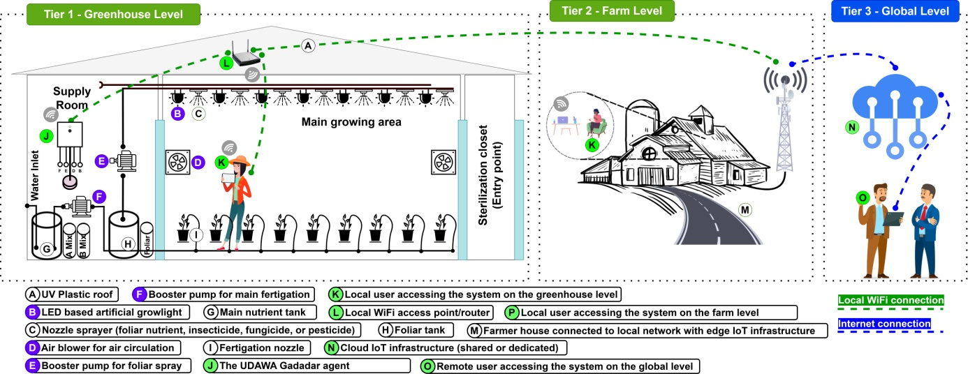

Figure 1. Small-scale horticulture greenhouse model and the big picture of the multi-tier agent-based cyber-physical system   
for small-scale horticulture

To develop an effective cyber-physical agent for greenhouse management, the 5C CPS architecture (Connection, Conversion, Cyber, Cognition, and Configuration) was chosen as a guiding framework [38], [45]. This framework facilitates the integration of physical and cyber elements into a unified, adaptive system. This study concentrates on precise instrument control [19], a critical aspect of small-scale greenhouse farming. Targeted instruments include fertigation pumps (Figure 1.F), foliar pumps (Figure 1.E), blowers (Figure 1.D), and grow lights (Figure 1.B), as their optimal operation directly impacts greenhouse efficiency and sustainability.

The first prototype agent, UDAWA Gadadar, is designed for universal instrument control and monitoring as shown in Figure 2. Following the 5C framework, UDAWA Gadadar's design incorporates the following features: Connection ensures reliable connectivity and appropriate sensors/actuators (e.g., electrical power sensors) for greenhouse instrument monitoring and control. Conversion equips the agent to transform data into actionable information for farmers, such as for prognostics and predictive maintenance [46], enabling proactive prevention of operational disruptions. Cyber ensures standardized M2M communication protocols for data exchange and analysis, fostering collaboration and data-driven decision-making.

Cognition enables connection to the farm level (Tier 2) for integrated data analysis and decision support. Finally, Configuration leverages the insights from the Cognition aspect to enable autonomous agent operation for optimized efficiency and environmental control. This 5C-based architecture informs the application architecture for UDAWA Gadadar, encompassing both hardware and software designs, and serves as a blueprint for system development to achieve digitalization and optimization of small-scale greenhouse management.

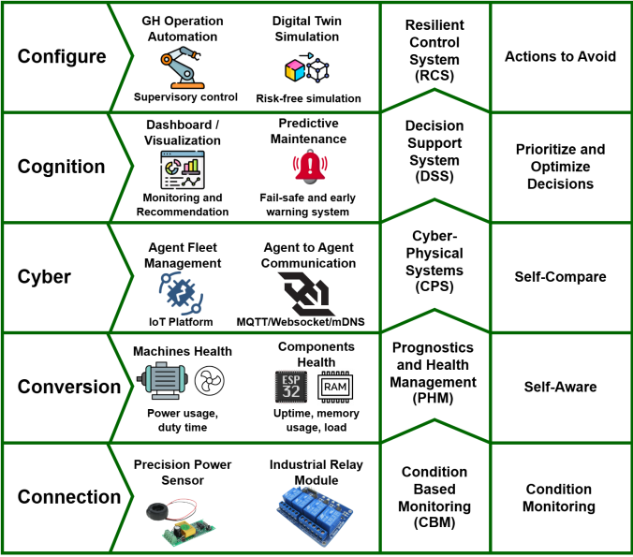

Figure 2. 5C architecture of the UDAWA Gadadar agent

## 2.2 UDAWA Gadadar Agent Hardware Design

The UDAWA Gadadar hardware employs a modular design using readily available electronic components with extensive community support [47], enabling farmers to customize and maintain the system cost-effectively. This approach promotes self-reliance in system management. As shown in Figure 3, the ESP32 microcontroller, chosen for its low power consumption, processing capabilities, and community support [47], serves as the central processing unit. Its energy efficiency is crucial for continuous operation, while its processing power supports real-time control and monitoring. A power sensor measures electrical parameters (current, voltage, power, power factor, frequency, and energy consumption) to provide real-time performance data for greenhouse instruments, facilitating prompt identification of malfunctions or inefficiencies. A four-channel relay module controls greenhouse loads (e.g., fertigation pumps, blowers, grow lights), allowing independent operation based on plant needs and environmental conditions. Finally, an integrated Miniature Circuit Breaker (MCB) provides essential safety against overloads and short circuits, protecting the hardware, connected instruments, and users.

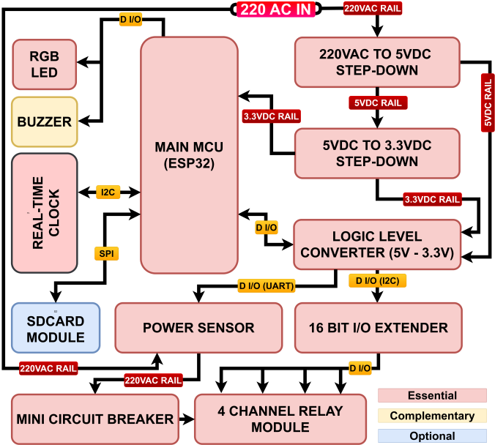

Figure 3.The hardware block diagram of the UDAWA Gadadar agent

## 2.3 UDAWA Gadadar Agent Software Design

The UDAWA Gadadar agent software, designed with a farmer-centric approach, prioritizes ease of use. Its architecture, as shown in Figure 4, comprises several key components: a core routine, storage I/O queue, HTTP/Websocket I/O queue, secure MQTT I/O queue, and agent-specific task routines.

The core routine provides reusable codes for future UDAWA agent variants. The storage I/O queue manages data storage on both the embedded LittleFS media and an external SD card, storing firmware for the built-in web interface and sensor data. This interface enables real-time monitoring and control. The HTTP/WebSocket I/O queue serves HTTP and WebSocket communication, providing the web interface and a secure WebSocket API (using basic authentication and salted HMAC) for UI and inter-agent data exchange. The Secure MQTT I/O queue handles communication with farm-level (Tier 2) agents on an edge computing IoT platform, enabling data transmission and control instruction reception.

The power sensor task routine includes a sampler, which collects and filters voltage, current, power, power factor, frequency, and total power usage (kWh) data before sending it to subscribers like the web UI or MQTT logger. A health watchdog detects sensor or greenhouse instrument errors (e.g., unread sensors, relays off with power flow) and notifies users via the UI or logger.

The relay control task routine features a controller that manages four relay operating modes: manual, duty-cycle, time-based, and AI. Each channel operates independently. The health watchdog prevents relay overrun and monitors instrument damage by querying the power sensor task routine. Finally, the agent-specific RPC task routine facilitates communication and information exchange with other local network agents, enabling data requests and provision for an integrated system.

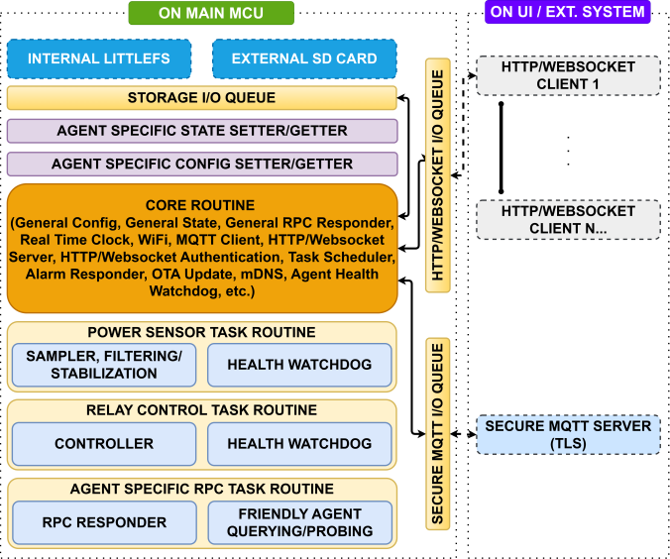

Figure 4.The software block diagram of the UDAWA Gadadar agent

## 2.4 System Validation and Testing

System validation and testing were conducted comprehensively to ensure the relevance and performance of the designed system. This process involved three main stages designed to evaluate various aspects of the system, ranging from functionality to compatibility with small-scale greenhouse models.

The first stage focused on testing the features implemented in the UDAWA Gadadar agent. An agent prototype was built to facilitate this testing process. This prototype was then used to identify features that had been successfully realized based on the designed system. The results of this feature testing are presented in the form of a table of implemented technical features in the results and discussion section to provide a visual overview of the capabilities and functions of the UDAWA Gadadar agent.

The second stage involved performance and cost analysis of the UDAWA Gadadar agent prototype. Performance analysis was conducted by evaluating several key parameters, including memory leak testing and the availability of memory resources for artificial intelligence (AI) and machine learning (ML)-based development at the edge. This testing was conducted to ensure that the UDAWA Gadadar agent has sufficient resources to accommodate future AI and ML features, which can enhance the system's ability to adapt to environmental conditions and plant needs. In addition, prototype procurement cost calculations and estimated maintenance costs were also performed. This information is important to provide small-scale farmers with an overview of the feasibility of adopting this technology, ensuring that the system is cost-effective and accessible to farmers with limited resources.

The third stage was designed to evaluate the relevance of the UDAWA Gadadar system for various small-scale greenhouse models. A decision matrix approach was chosen due to its ability to facilitate a structured and objective comparison of several greenhouse models based on predetermined criteria [48]. This decision matrix consists of rows representing greenhouse models and columns representing evaluation criteria. The evaluated greenhouse models are shown in Table 1. This table presents five greenhouse models mapped based on field observation results in Pancasari Village, Buleleng Regency, Bali. Each model has attributes that provide detailed information about how their business is run, the types of commodities grown, connectivity availability, and the types of instruments used in the greenhouse.

Table 1. Small-scale greenhouse models in Pancasari Village, Buleleng Regency, Bali

|  |  |  |  |  |  |  |  |  |
| --- | --- | --- | --- | --- | --- | --- | --- | --- |
| GH Model | Business Model | Commodity | Farming Method | Wireless Connectivity | Pump | Fan | Lighting | Solenoid |
| GH1 | Market gardener | Lettuce | NFT Hydroponic | WiFi | 3 | 2 | 0 | 1 |
| GH2 | Agri-tourism farmer | Flower | Drip Fertigation | None | 1 | 1 | 0 | 1 |
| GH3 | Market gardener | Bell pepper | Drip Fertigation (Hydroponic) | WiFi | 2 | 1 | 1 | 0 |
| GH4 | Market gardener | Tomato | Organic | None | 1 | 0 | 0 | 1 |
| GH5 | Agri-tourism farmer | Strawberry | Drip Fertigation | WiFi / 4G | 2 | 0 | 1 | 0 |

Three key criteria were selected to assess the potential adoption of the UDAWA Gadadar system in each greenhouse: C1: **Connectivity** – Evaluating the availability of WiFi access or smartphones for the system; C2: **Affordability** – Considering the farmers' budget and willingness to invest in the system; and C3: **Integration** – Assessing the ability of the IoT agent to accommodate existing greenhouse instruments. These criteria were selected based on field observations and represent the most essential factors influencing system adoption. Each criterion was weighted based on its significance: Connectivity (C1): 40%, Affordability (C2): 30%, and Integration (C3): 30%. This weighting reflects the relative importance of each criterion in determining the successful implementation of the UDAWA Gadadar system.

Each greenhouse model was evaluated against the criteria on a scale of 1 to 5: 1 = Poor compatibility, 3 = Moderate compatibility, and 5 = Excellent compatibility. This scale allows for a quantitative assessment of each greenhouse model against the established criteria. The ground rule for assessing connectivity is that if a WiFi network and a smartphone are available, it is rated excellent; if only a smartphone or WiFi is available, it is rated good; and if neither is available, it is rated poor. For affordability, we assessed subjectively based on the annual income of the farmers we observed and their willingness to implement digitalization in their greenhouses. For compatibility, we assessed based on the number of instruments in the greenhouse with the number of relay channels owned by the prototype model. If the number of relay channels is sufficient to control the instruments, the value is better.

To account for the criteria weights, the score for each greenhouse model was normalized. Normalization was performed by dividing the individual score by the total column score.

The normalized value was then multiplied by the respective weight to calculate the weighted score for each criterion. The total weighted score for each greenhouse model was used to determine its relevance to the UDAWA Gadadar system.

# 3. Results and Discussions

## 3.1 Implementation of Cyber-Physical Agents

Before fabricating the UDAWA Gadadar prototype, we conducted design and assembly simulations using Fusion 360 software. The simulation, whose results are displayed in Figure 5, allowed us to visualize and test the prototype design virtually, including the placement of internal and external components, as well as identify potential design or assembly issues before the physical prototype was built. The UDAWA Gadadar prototype was designed with dimensions of 220x210x100mm, which were deemed suitable for easy integration with various small-scale greenhouse models.

Utilizing this 3D design simulation provides several advantages. First, it helps reduce prototype development costs, particularly in terms of the early identification and resolution of design issues. Second, it allows us to efficiently explore various design options and hardware configurations, including determining how to connect the prototype universally with greenhouse instruments. This process is crucial for ensuring that the resulting prototype is easy for farmers to assemble, maintain, and upgrade. Moreover, this simulation also assists us in optimizing the layout of the internal components to maximize space and cooling efficiency. The 3D design results in STL format were then exported and printed using a 3D printer to create the prototype casing.

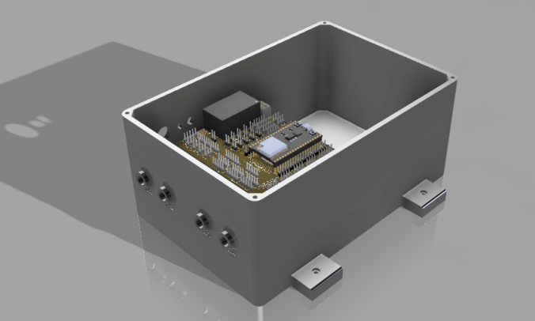

Figure 5.The CAD model of the UDAWA Gadadar Agent

Figure 6 illustrates the internal arrangement of the UDAWA Gadadar agent hardware, comprising a mainboard, a power sensor module, a relay module, and other supporting components. The mainboard is designed with universality in mind to accommodate various UDAWA agent variants in the future. This PCB mainboard can be interfaced with a range of sensors, actuators, and common modules applicable to smart farming, thus enabling system development and adaptation as needed.

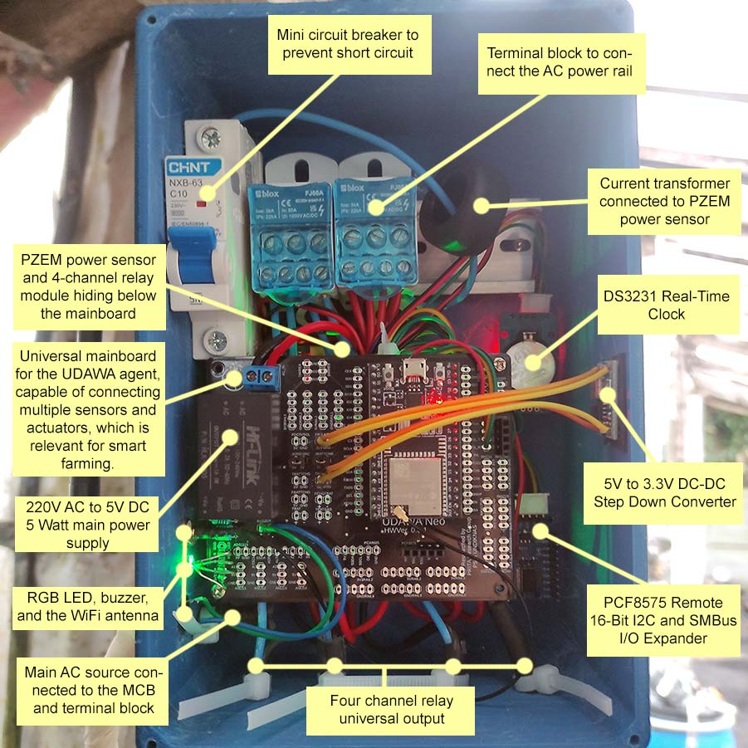

Figure 6. The build-up of the UDAWA Gadadar agent, showing how each component connected and hooked

The PZEM-004T power sensor module, equipped with a current transformer, is utilized to measure electrical parameters such as current, voltage, and power. This module is connected to the ESP32 through a Logic Level Converter to ensure voltage compatibility and accurate serial communication. Additionally, a DS3231 real-time clock module is integrated to maintain timekeeping accuracy even when the device is offline.

Safety and neatness of the electrical installation are prioritized in the design of the UDAWA Gadadar agent. The use of terminal blocks for connecting high-voltage cables enhances safety and facilitates maintenance. A Mini Circuit Breaker (MCB) is also integrated to protect the internal electrical installation from short circuits, thereby preventing potential fire hazards and device damage. On the underside of the mainboard, a four-channel relay module with optocouplers enables independent control of various greenhouse instruments.

To provide visual indication of the agent's operational status, an RGB LED and a buzzer are embedded as physical indicators. The RGB LED will illuminate red if the agent is in offline mode, green if connected to WiFi, and blue if connected to tier 2 or 3. The LED and buzzer will also blink and sound an alarm if abnormal conditions occur, such as sensor errors or greenhouse instrument load faults.

After the UDAWA Gadadar prototype fabrication was completed, we conducted on-site installation and testing. The prototype was installed in a strawberry greenhouse representative of greenhouse model number 5 (GH5) in Table 1. This greenhouse model was selected based on the decision matrix analysis results in Table 5, where GH5 showed the second-highest relevance score to the UDAWA Gadadar system. We initially planned to conduct testing in GH3 as the most relevant model; however, considering that the farm is a production farm implementing certified standards, we shifted the testing to ensure it did not negatively impact the farmer's yield.

In this installation and testing phase, the UDAWA Gadadar prototype was connected to three greenhouse instruments: the fertigation pump, foliar pump, and lighting, as shown in Figure 7. This testing aimed to ensure that the prototype could function properly in real-world conditions and integrate with instruments commonly used in small-scale greenhouses. The test results showed that the UDAWA Gadadar agent could control and monitor the three instruments in real-time through the designed web interface.

An interesting finding from this installation process was the identification of the most effective method for connecting the UDAWA Gadadar agent to greenhouse instruments. The use of hanging plug sockets, which are readily available in electronics stores, proved to be a simple, practical, and safe solution. In addition to facilitating installation, the use of hanging plug sockets provides flexibility for farmers to move greenhouse instruments as needed without modifying the electrical installation.

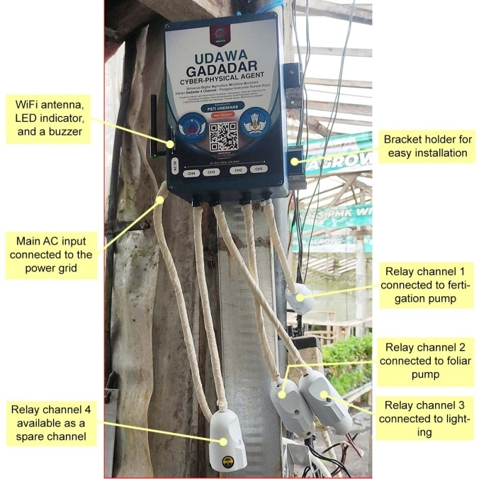

Figure 7. The installation of the UDAWA Gadadar agent at one of the strawberry greenhouse, showing three greenhouse instruments connected to the universal plug

Figure 8 illustrates the built-in embedded web interface of UDAWA Gadadar, which serves as an access point for farmers at the tier 1 level. Tier 1 can be operated using only a smartphone connected directly to the UDAWA agent on the local network or peer-to-peer via the built-in AP mode on the UDAWA agent side. This allows farmers to access the UDAWA Gadadar agent interface through a web browser on their smartphones without requiring additional hardware, such as a computer or tablet or installing applications that burden their phones. This ease of access is crucial, especially given the high penetration rate of smartphones in Indonesia, which means that most small farmers already have access to this technology. Thanks to the mDNS service, we can set up a local domain, which helps farmers easily access the web interface.

Figure 8 also displays the main pages of the embedded web interface embedded in the UDAWA Gadadar agent. This interface is designed using the Preact framework which is known to be lightweight and efficient, so it is able to run optimally on the ESP32 microcontroller with limited resources. Basic features have been implemented, including the initial setup page (Figure 8.A), setup success confirmation page (Figure 8.B), login page (Figure 8.C), channel selection page (Figure 8.D), channel configuration page (Figure 8.E), and the main page which displays power usage and channel status (Figure 8.F). Although not yet equipped with data logging and advanced analytics capabilities, this interface already provides farmers with the ability to manage UDAWA Gadadar agents and monitor greenhouse instrument conditions through real-time data obtained from power sensors, including conversion of electricity costs from kWh to local currency rates.

The ability to monitor power usage and electricity costs in real-time provides transparency to farmers about energy efficiency in their greenhouses, allowing them to take the necessary actions to optimize energy use and reduce operating costs.

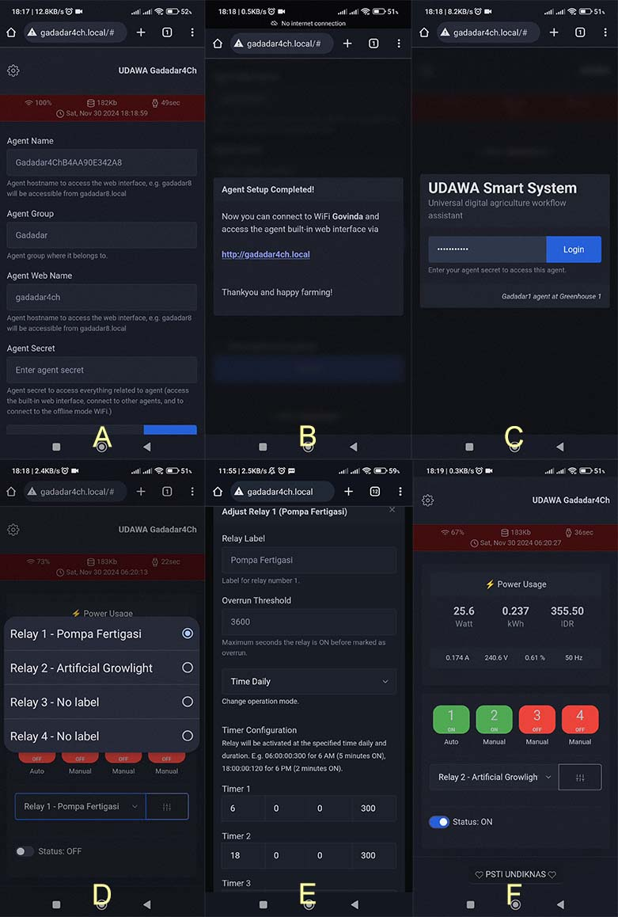

Figure 8. The built-in web interface: (A) the initial setup page, (B) setup success confirmation, (C) login page, (D) channel selection, (E) channel configuration; and (F) main page showing the power usage and channel status

One interesting finding at this stage is the success in compiling the web interface into a 208KB file, so that it can be loaded into the ESP32's internal flash memory. Once loaded via HTTP, the interface running on the farmer's cellphone connects to the UDAWA Gadadar agent via websocket communication, allowing real-time control and monitoring. The use of websockets enables fast and efficient two-way communication between the user interface and the agent, so that data can be updated dynamically without having to reload the web page. This creates an interactive and responsive user experience, increasing the ease of use of the UDAWA Gadadar system for farmers.

In addition to the physical prototype of the UDAWA Gadadar agent that was developed and field-tested as illustrated in Figure 6 and Figure 7, the development of the UDAWA system also includes prototype implementation at tier 2 and tier 3 levels. The prototypes at tier 2 and tier 3 were built utilizing other open-source solutions loaded in the form of an IoT platform.

The IoT platform chosen for this purpose is Thingsboard Community Edition (TBCE) version 3.8.1. TBCE was chosen due to several advantages it offers. First, TBCE is a highly flexible and easily developed platform, allowing unlimited development for features needed in managing farmer data and information in the future. Second, TBCE is equipped with a powerful rule engine that enables automation and arrangement of complex workflows. Third, TBCE has an edge version that can be easily deployed on edge devices such as Raspberry PI and can be automatically synchronized with the main server on the internet. In its implementation, TBCE is deployed on an edge device in the form of a Raspberry PI 5 placed at the agricultural location (tier 2) and on a virtual private server located on the internet (tier 3). Figure 9 illustrates the interface of the Thingsboard IoT platform used in tier 2 and tier 3.

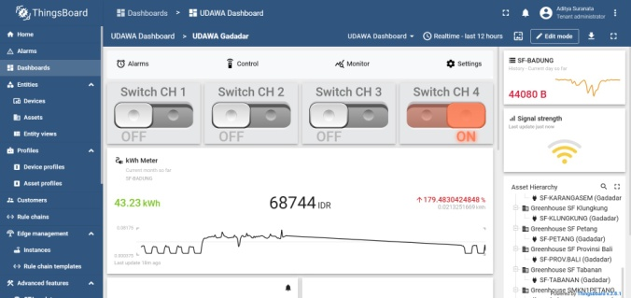

Figure 9. The interface of the Thingsboard IoT platform in Tier 2 (edge, Raspberry Pi 5, 2GB RAM, 32GB storage) or Tier 3 (cloud, VPS 1 core, 1GB RAM, 25GB storage).

The use of TBCE at tier 2 and tier 3 opens up opportunities for wider UDAWA system development. One interesting finding from the use of TBCE is the prospect of further development towards a digital twin. A digital twin is a digital replica of a physical object, in this case, a greenhouse along with all the instruments and plants in it. With a digital twin, farmers can perform simulations and experiments in the digital world without having to directly intervene in the physical greenhouse. This can help farmers optimize cultivation strategies, reduce the risk of failure, and increase operational efficiency.

## 3.2 Agent Cost and Performance Analysis

Figures 10 and 11 present the recorded data of memory usage for the UDAWA Gadadar agent installed in greenhouse GH5. The device was operated normally, with farmers accessing the built-in web interface, the agent connected to tiers 2 and 3, and relay control modes in both manual and automatic settings. It is important to note that measuring resource usage in embedded devices is challenging; therefore, the measurements shown in Figures 10 and 11 may not fully represent the device's actual memory usage. The remaining memory may not be entirely allocatable, especially in cases of memory segmentation. The ESP32 device also has different memory types with their respective blocks.

Nevertheless, by observing the heap memory snapshot, we can gain a general overview of the remaining device resources. Figure 10 shows that the average remaining memory is 175KB when the device operates in non-SSL mode. This available memory is sufficient for executing the agent's basic functions, such as sensor readings, relay control, and communication with tiers 2 and 3.

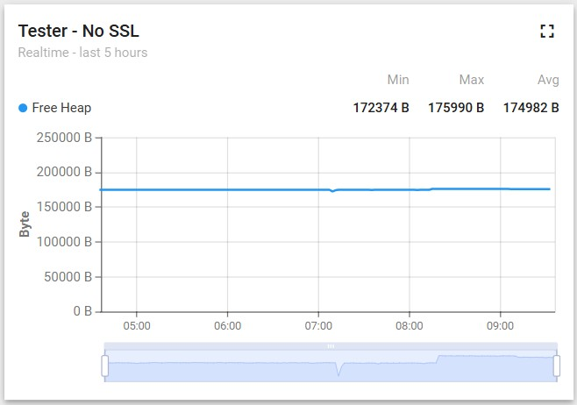

Figure 10. The free heap graph of the agent (with SSL disabled)

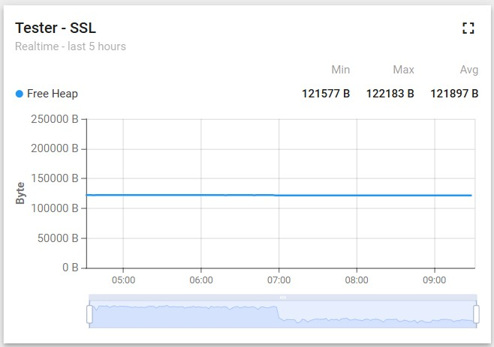

Figure 11. The free heap graph of the agent (with SSL enabled)

However, when SSL mode is enabled, the average remaining memory decreases to 122KB, as depicted in Figure 11. This reduction of approximately 53KB indicates that SSL encryption requires significant memory allocation. Although this decrease does not impact the agent's performance in executing its basic functions, it necessitates consideration for the development of advanced features in the future. The remaining memory will influence the feasibility of implementing advanced features at the edge, embedded directly within the agent, such as machine learning models for predictive maintenance purposes. Machine learning models, particularly those based on deep learning, require substantial memory for efficient operation. Since the connection between agents occurs on a local network, security at the Data Link Layer (Layer 2 in the OSI Model) can be used as a solution to mitigate security threats. For instance, agents can secure their communication using the WPA2-PSK encryption standard.

Therefore, memory usage optimization is necessary to enable the UDAWA Gadadar agent to accommodate these advanced features. One optimization strategy that can be implemented is disabling SSL encryption on the edge side when the agent communicates with tier 2. This strategy is feasible because communication between the agent and tier 2 occurs within a relatively secure local network. Security can be strengthened by implementing additional security protocols at the WiFi network level, such as WPA3 encryption and access control lists. SSL connection is only mandatory if the agent connects directly to the tier 3 level via the internet. By eliminating SSL on the edge side, the remaining memory can be allocated to run machine learning models, allowing the UDAWA Gadadar agent to provide services such as predictive maintenance that can assist farmers in preventing instrument damage and reducing maintenance costs. Ultimately, a non-decreasing line graph over a comprehensive testing period proves that the device is free from memory leaks. To ensure proper integration between the sensors and actuators within the UDAWA Gadadar system, we conducted comprehensive testing on the sensor's data reading capabilities and actuator control. The primary focus of this testing was to validate the sensor's performance in accurately recording data and the actuator's ability to respond precisely to control commands.

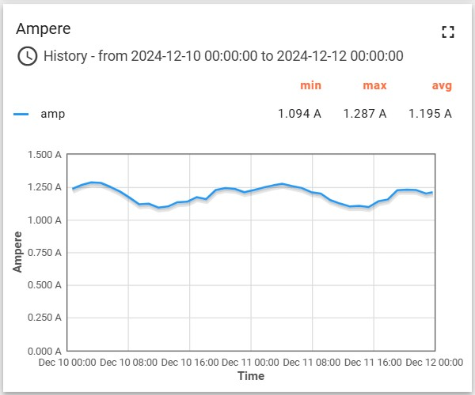

Figure 12. The amperage data from the sensor reading test

Figure 12 presents historical data of the electrical current readings driving the fertigation pump. The data indicates that the current sensor on the UDAWA Gadadar agent is capable of recording current ratings that align with the pump's specifications. Minor fluctuations observed in the data are attributed to environmental factors such as temperature variations and pressure changes within the fertigation pipeline. Although the PZEM-004T sensor utilized in this research can measure various other electrical parameters, including voltage, active power, power factor, and frequency, the amperage value is considered sufficiently representative for evaluating sensor performance. The results of this test confirm that the sensor functions correctly and provides validated data as the same as the power rating of the pump.

Figure 13 illustrates the switching history of the relay channels from on to off states and vice versa. This data, collected since the initial stages of prototype development, clearly demonstrates the precise activation and deactivation of each relay channel. Status changes on the relay channels within the web interface are consistently reflected in the corresponding physical relays. This test result validates the capability of the UDAWA Gadadar agent to reliably control the relay actuators.

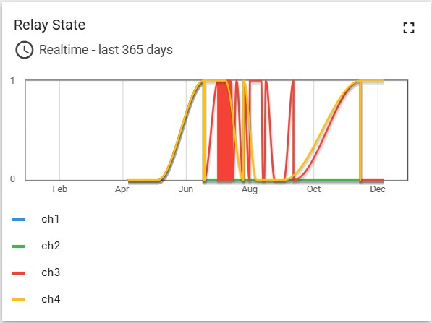

Figure 13. The sampled data from relay channel switching test

The data generated from the power sensor features and relay control patterns, as depicted in Figures 12 and 13, hold significant potential for further analysis. This analysis can be utilized to develop more effective predictive control and monitoring models for future greenhouse instruments. The utilization of historical data and operational patterns of the instruments enables the optimization of performance, energy efficiency, and predictive maintenance strategies, ultimately enhancing productivity and sustainability in greenhouse farming endeavors.

To conclude the analysis of the prototype's performance and cost, a comprehensive calculation of the procurement cost for all components required to assemble one unit of the UDAWA Gadadar agent was conducted, as presented in Table 2. This calculation aims to provide small-scale farmers with insights into the financial feasibility of implementing the proposed digitalization solution. The results indicate that the total component cost for a single UDAWA Gadadar agent unit, operable at tier 1 (greenhouse level), amounts to USD 33.7.

It is important to note that this cost does not include component shipping and assembly services, which may vary depending on the location and service provider, including the cost of setting up a WiFi network in the farmer's garden if the farmer does not already have one. Nevertheless, this figure indicates that the component procurement cost for one unit of the UDAWA Gadadar agent is relatively affordable, especially when compared to the investment cost for agricultural digitalization solutions that generally target industrial-scale farmers.

Table 2. Bill of material of the UDAWA Gadadar agent prototype (excluding shipping and assembly cost)

|  |  |  |
| --- | --- | --- |
| Items | Qty | Total Price (USD) |
| ESP32 DevKitC 32U | 1 | 5 |
| Bidirectional Logic Level Converter 5-3v3 | 1 | 0.5 |
| Surface Finish PCB 10x10Cm | 1 | 1 |
| 3D printer case PLA+ 2.0 22x21mm | 1 | 5 |
| 8dBi 2.4GHz SMA Antenna | 1 | 0.9 |
| RGB LED | 1 | 0.1 |
| Active buzzer | 1 | 0.2 |
| Power distribution block | 2 | 2.2 |
| MCB 6A 6KA | 1 | 2 |
| PZEM-004T with Current Transformer | 1 | 6.3 |
| DS3231 real-time clock module | 1 | 1.5 |
| Relay module 4 channel with optocoupler | 3.5 | 4 |
| 2.5mm power cable 3.5 meters |  |  |
| Electric plugs male power inlet | 1 | 1 |
| Hanging electric plugs female power outlet | 4 | 4 |
| Total components cost of tier 1 UDAWA Gadadar agent | | 33.7 |
| Raspberry Pi 5 SC1110 2GB RAM 4 Core | 1 | 50 |
| Passive cooling case ED-PI5CASE-OS | 1 | 7 |
| 27W USB-C PSU EU | 1 | 12 |
| Sandisk Ultra MicroSD 32GB | 1 | 5 |
| Total components cost of Tier 2 (up to100 devices) | | 74 |
| Cloud virtual machine 1 vCPU 1GB RAM 25 GB storage (per month) for Tier 3 (up to 100 devices) | 1 | 6 |

Furthermore, we also analyzed the component procurement costs for tier 2 and tier 3 implementations of the UDAWA system. The tier 2 implementation allows farmers to perform data logging and further analysis of their entire greenhouse. This tier 2 requires additional infrastructure in the form of edge computing devices such as Raspberry Pi which are placed at the farm location and connected to all UDAWA Gadadar agents via a local network. The component procurement cost for this tier 2 is USD 74.

Meanwhile, tier 3 allows farmers to have global access via the internet to all their garden assets. This tier 3 is implemented using a cloud server that can be accessed from anywhere. The cloud server rental cost for this tier 3 is USD 6 per month. It should be emphasized that the cost calculation in tier 2 and tier 3 is carried out based on recommendations from Thingsboard [49] for minimum service coverage capable of serving up to 100 UDAWA Gadadar agent units and standard prices for virtual server specifications. Although farmers can use a free domain for their cloud server, additional costs may arise for renting a special domain if the farmer wants it.

For small-scale farmers who have limited capital, cooperation with farmer groups can be a strategic alternative in reducing the investment cost burden in tier 2 or tier 3. By building infrastructure collectively, farmers can share access to data and information, and take advantage of the UDAWA system optimally at a more affordable cost.

## 3.3 Multicase Study Analysis of System Design

The research location in Pancasari Village, Buleleng Regency, Bali, demonstrates an interesting diversity in the implementation of small-scale greenhouses. Our field observations identified various types of greenhouses used for cultivating diverse commodities, ranging from vegetables such as lettuce and peppers to fruits like strawberries, operated under different business models, namely market gardener and agri-tourism farmer. This diversity provides a good opportunity to test the relevance of the UDAWA platform we have developed. To that end, we conducted a multicase study analysis with a decision matrix approach to evaluate how well our platform can be adopted in these various greenhouse models.

It is important to note that this multicase study analysis has limitations. The complexity of research in the early stages of UDAWA platform development, which demands a focus on completing technical aspects, limits us from conducting ideal validation involving direct feedback from farmers. Nevertheless, this decision matrix analysis still provides a valuable initial overview of the relevance and potential adoption of the UDAWA platform in various small-scale greenhouse models.

Table 3. Raw score decision matrix for each greenhouse model

|  |  |  |  |
| --- | --- | --- | --- |
| GH Model | C1 (Connectivity) | C2 (Affordability) | C3 (Integration) |
| GH1 | 5 | 3 | 3 |
| GH2 | 3 | 3 | 3 |
| GH3 | 5 | 4 | 5 |
| GH4 | 1 | 1 | 2 |
| GH5 | 5 | 5 | 4 |
| Total | 19 | 16 | 17 |

Table 4. Normalized score decision matrix for each greenhouse model

|  |  |  |  |
| --- | --- | --- | --- |
| GH Model | C1 (Connectivity) | C2 (Affordability) | C3 (Integration) |
| GH1 | 0.26 | 0.19 | 0.18 |
| GH2 | 0.16 | 0.19 | 0.18 |
| GH3 | 0.26 | 0.25 | 0.29 |
| GH4 | 0.05 | 0.06 | 0.12 |
| GH5 | 0.26 | 0.31 | 0.24 |
| Total | 1.00 | 1.00 | 1.00 |

Table 3 presents the raw score assessment results for each greenhouse model based on the criteria defined in the research methodology. These criteria, namely connectivity, affordability, and integration, were selected based on field observation results and represent key factors influencing farmers' ability and willingness to adopt digital technology. Table 4 then displays the normalization results of the raw scores, allowing for a fairer comparison between greenhouse models. Normalization is carried out by dividing the raw score by the total score for each criterion. Finally, Table 5 presents the weighted scores and final scores for each greenhouse model. The weighted score is calculated by multiplying the normalized score by the weight of each criterion, reflecting the relative importance level of each criterion in determining the success of UDAWA system adoption.

The analysis of the decision matrix reveals that greenhouse models GH3 and GH5 exhibit the highest relevance scores with the Gadadar variant of the UDAWA platform. GH3, operated under a market gardener business model and cultivating peppers, along with GH5, which implements an agri-tourism business model with strawberries as its commodity, demonstrate favorable compatibility in terms of connectivity, affordability, and integration. Conversely, the GH4 model, employing organic farming practices for tomato cultivation, indicates the lowest relevance. Although farmers utilizing the GH4 model express significant interest in open-source digitalization solutions, limited access to funding and digital resources constitutes a major obstacle to the implementation of the Gadadar variant of UDAWA.

Table 5. Weighted score decision matrix for each greenhouse model

|  |  |  |  |  |
| --- | --- | --- | --- | --- |
| GH Model | C1 (Connectivity) | C2 (Affordability) | C3 (Integration) | Final Score |
| GH1 | 0.11 | 0.06 | 0.05 | 0.21 |
| GH2 | 0.06 | 0.06 | 0.05 | 0.17 |
| GH3 | 0.11 | 0.08 | 0.09 | 0.27 |
| GH4 | 0.02 | 0.02 | 0.04 | 0.08 |
| GH5 | 0.11 | 0.09 | 0.07 | 0.27 |
| Weight | 0.40 | 0.30 | 0.30 | 1 |

## 3.4 System Limitations and Implementation Challenges

It is essential to acknowledge that this study has certain limitations. Primarily, only one agent was implemented to showcase the proposed architecture, with Tiers 2 and 3 only partially implemented. This limitation impacted the depth of the multicase study analysis, as comprehensive validation involving direct feedback from farmers across all tiers was not feasible in the early stages of UDAWA platform development.

Future research will prioritize expanding the implementation to encompass multiple agents and complete the development of Tiers 2 and 3, enabling a more thorough evaluation of the system's functionality, interoperability, and scalability in diverse real-world settings. Additionally, while the decision matrix analysis provided valuable insights into the potential adoption of the UDAWA platform, it is crucial to acknowledge the inherent subjectivity in the assessment process, particularly regarding affordability and integration criteria.

# 4. Conclusions

This research successfully designed and developed an intelligent system platform called UDAWA (Universal Digital Agriculture Workflow Assistant) for the digitalization of small-scale greenhouses. UDAWA Gadadar, the first variant of this platform, has been implemented as a cyber-physical agent that allows greenhouse instruments, such as pumps, blowers, and lamps, to be digitally controlled and monitored. Test results indicate that UDAWA Gadadar exhibits good performance and cost-effectiveness, making it relatively affordable for small-scale farmers. A multicase study analysis demonstrates that this platform has high relevance for adoption in various greenhouse models.

Further development of the UDAWA platform will focus on developing other physical agent variants, such as hydroponic water condition monitors, microclimate monitors, and visual sensor agents for disease and pest detection. Additionally, the development of a digital twin will be prioritized to enable risk-free and low-cost cultivation simulations, thereby assisting small-scale farmers in optimizing cultivation strategies and increasing productivity.

**Acknowledgements**

This research was funded by the Ministry of Education, Culture, Research, and Technology of the Republic of Indonesia and the Universitas Pendidikan Nasional based on Decree No. 110/E5/PG.02.00.PL/2024 and Agreement/Contract No. 2927/LL8/AL.04/2024.

# References

[1] Á. J. Pastrana-Pastrana, R. Rodríguez-Herrera, J. F. Solanilla-Duque, and A. C. Flores-Gallegos, “Plant proteins, insects, edible mushrooms and algae: more sustainable alternatives to conventional animal protein,” *Journal of Future Foods*, vol. 5, no. 3, pp. 248–256, May 2025, doi: 10.1016/j.jfutfo.2024.07.004.

[2] D. Ortiz-Miranda *et al.*, “The future of small farms and small food businesses as actors in regional food security: A participatory scenario analysis from Europe and Africa,” *Journal of Rural Studies*, vol. 95, pp. 326–335, Oct. 2022, doi: 10.1016/j.jrurstud.2022.09.006.

[3] Amanullah, *Crop nutrition: Enhancing healthy soils, food security, environmental sustainability and advancing SDGs*. in Crop Nutrition: Enhancing Healthy Soils, Food Security, Environmental Sustainability and Advancing SDGs. 2024, p. 690. doi: 10.1515/9783111617671.

[4] “Planetary health and its relevance in the modern era: A topical review.” Accessed: Dec. 29, 2024. [Online]. Available: https://journals.sagepub.com/doi/epub/10.1177/20503121241254231

[5] F. Su *et al.*, “Distribution, taxonomy, phylogeny, phytochemistry, pharmacology, and artificial cultivation of tribe Podophylleae for podophyllotoxin production,” *Industrial Crops and Products*, vol. 222, p. 119862, Dec. 2024, doi: 10.1016/j.indcrop.2024.119862.

[6] G. Kountios, “The role of agricultural consultants and precision agriculture in the adoption of good agricultural practices and sustainable water management,” *International Journal of Sustainable Agricultural Management and Informatics*, vol. 8, no. 2, pp. 144–155, 2022, doi: 10.1504/IJSAMI.2022.124577.

[7] M. Jastrzębska, M. Kostrzewska, and A. Saeid, “Sustainable agriculture: A challenge for the future,” in *Smart Agrochemicals for Sustainable Agriculture*, 2021, pp. 29–56. doi: 10.1016/B978-0-12-817036-6.00002-9.

[8] W. Saeys and J. De Baerdemaeker, “Precision agriculture technology for sustainable good agricultural practice,” presented at the Conference Proceeding - 5th International Conference, TAE 2013: Trends in Agricultural Engineering 2013, 2013, pp. 19–24.

[9] J. D. Baerdemaeker and W. Saeys, “Good Agricultural Practices, Quality, Traceability, and Precision Agriculture,” in *Precision Agriculture Technology for Crop Farming*, 2015, pp. 279–298. doi: 10.1201/b19336-9.

[10] C. Kashyap, B. Y. Kashyap, K. Guruprasad, D. Shrinivasa, and P. K. Shrivastava, “Recent development of automation and IoT in agriculture,” *International Journal of Recent Technology and Engineering*, vol. 8, no. 2 Special Issue 3, pp. 820–823, 2019, doi: 10.35940/ijrte.B1153.0782S319.

[11] F. Xu *et al.*, “Review of good agricultural practices for smallholder maize farmers to minimise aflatoxin contamination,” *WMJ*, vol. 15, no. 2, pp. 171–186, Apr. 2022, doi: 10.3920/WMJ2021.2685.

[12] C. C. Krejci, A. A. Marusak, N. Sadeghiamirshahidi, A. Mittal, and S. Beckwith, “Transportation barriers in local and regional food supply chains,” *Journal of Agriculture, Food Systems, and Community Development*, vol. 14, no. 1, 2024, doi: 10.5304/jafscd.2024.141.018.

[13] K. Darwis, M. Salam, M. Munizu, and P. Diansari, “A review of global research trends on the impact of the COVID-19 pandemic on food security,” *Agriculture and Food Security*, vol. 13, no. 1, 2024, doi: 10.1186/s40066-024-00496-y.

[14] C. B. Sibiya, L. M. Maesela, M. A. Ramashala, and G. M. Senyolo, “Determinants of Farm Income During Lockdown Restrictions Amongst Small-Scale Farmers in the Gauteng Province, South Africa,” *South African Journal of Agricultural Extension*, vol. 52, no. 5, pp. 136–150, 2024, doi: 10.17159/2413-3221/2024/v52n5a16705.

[15] E. Nkansah-Dwamena, “Why Small-Scale Circular Agriculture Is Central to Food Security and Environmental Sustainability in Sub-Saharan Africa? The Case of Ghana,” *Circular Economy and Sustainability*, vol. 4, no. 2, pp. 995–1019, 2024, doi: 10.1007/s43615-023-00320-y.

[16] A. Sahavacharin, F. Likitswat, K. N. Irvine, and L. Teang, “Community-Based Resilience Analysis (CoBRA) to Hazard Disruption: Case Study of a Peri-Urban Agricultural Community in Thailand,” *Land*, vol. 13, no. 9, 2024, doi: 10.3390/land13091363.

[17] N. Abed *et al.*, “Assessing farm-level agricultural sustainability in India: A comparative study using a mixed-method approach,” *Agricultural Systems*, vol. 224, 2025, doi: 10.1016/j.agsy.2024.104223.

[18] J. A. Brenes, G. López, F. J. Ferrández-Pastor, and G. Marín-Raventós, “Usability assessment of a greenhouse context-aware alert system for small-scale farmers,” *Frontiers in Computer Science*, vol. 6, 2024, doi: 10.3389/fcomp.2024.1412913.

[19] F. J. Ferrández-Pastor, J. M. Cámara-Zapata, S. Alcañiz-Lucas, S. Pardo, and J. A. Brenes, “Reinforcement Learning Model in Automated Greenhouse Control,” *Lecture Notes in Networks and Systems*, vol. 842 LNNS, pp. 3–13, 2023, doi: 10.1007/978-3-031-48642-5_1.

[20] H. Li, Y. Guo, H. Zhao, Y. Wang, and D. Chow, “Towards automated greenhouse: A state of the art review on greenhouse monitoring methods and technologies based on internet of things,” *Computers and Electronics in Agriculture*, vol. 191, 2021, doi: 10.1016/j.compag.2021.106558.

[21] S. Behroozeh, D. Hayati, and E. Karami, “Factors influencing energy consumption efficiency in greenhouse cropping systems,” *Environ Dev Sustain*, Apr. 2024, doi: 10.1007/s10668-024-04851-8.

[22] J. Chacha *et al.*, “Greenhouse and open-field Tomato farming. A comparison through yield and growth parameters investigated in Dar es Salaam,” *Innovations Agric*, pp. 1–9, 2023, doi: 10.25081/ia.2023-02.

[23] I. W. Supartha, I. W. Susila, Yohanes, I. K. W. Yudha, and P. A. Wiradana, “Potential of parasitoid *Gronotoma micromorpha* Perkin (Hymenoptera: Eucoilidae) as a biocontrol agent for pea leafminer fly, *Liriomyza huidobrensis* Blanchard (Diptera: Agromyzidae),” *Acta Ecologica Sinica*, vol. 42, no. 2, pp. 90–94, Apr. 2022, doi: 10.1016/j.chnaes.2021.06.008.

[24] U. Shareef, A. U. Rehman, and R. Ahmad, “A Systematic Literature Review on Parameters Optimization for Smart Hydroponic Systems,” *AI (Switzerland)*, vol. 5, no. 3, pp. 1517–1533, 2024, doi: 10.3390/ai5030073.

[25] S. Dhanasekar, “A comprehensive review on current issues and advancements of Internet of Things in precision agriculture,” *Computer Science Review*, vol. 55, 2025, doi: 10.1016/j.cosrev.2024.100694.

[26] N. Ahmed *et al.*, “Advancing horizons in vegetable cultivation: a journey from ageold practices to high-tech greenhouse cultivation—a review,” *Front. Plant Sci.*, vol. 15, Apr. 2024, doi: 10.3389/fpls.2024.1357153.

[27] S. Argento, G. Garcia, and S. Treccarichi, “Sustainable and Low-Input Techniques in Mediterranean Greenhouse Vegetable Production,” *Horticulturae*, vol. 10, no. 9, Art. no. 9, Sep. 2024, doi: 10.3390/horticulturae10090997.

[28] M. F. Rabbee, Md. S. Ali, Md. N. Islam, M. M. Rahman, Md. M. Hasan, and K.-H. Baek, “Endophyte mediated biocontrol mechanisms of phytopathogens in agriculture,” *Research in Microbiology*, vol. 175, no. 8, p. 104229, Nov. 2024, doi: 10.1016/j.resmic.2024.104229.

[29] M. Khayatnezhad and F. Nasehi, “Industrial pesticides and a methods assessment for the reduction of associated risks: A review,” *Advancements in Life Sciences*, vol. 8, no. 2, pp. 202–210, 2021.

[30] J. Koller, L. Sutter, J. Gonthier, J. Collatz, and L. Norgrove, “Entomopathogens and Parasitoids Allied in Biocontrol: A Systematic Review,” *Pathogens*, vol. 12, no. 7, Art. no. 7, Jul. 2023, doi: 10.3390/pathogens12070957.

[31] J. A. Brenes and G. Marín-Raventós, “Scalable Technological Architecture Empowers Small-Scale Smart Farming Solutions,” *Communications of the ACM*, vol. 67, no. 8, pp. 93–94, 2024, doi: 10.1145/3653327.

[32] J. A. Brenes, A. Martínez, C. Quesada-López, and M. Jenkins, “Decision support systems that use artificial intelligence for precision agriculture: A systematic literature mapping,” *RISTI - Revista Iberica de Sistemas e Tecnologias de Informacao*, vol. 2020, no. E28, pp. 217–229, 2020.

[33] A. Gabriel and M. Gandorfer, “Adoption of digital technologies in agriculture—an inventory in a european small-scale farming region,” *Precision Agric*, vol. 24, no. 1, pp. 68–91, Feb. 2023, doi: 10.1007/s11119-022-09931-1.

[34] T. Mizik, “How can precision farming work on a small scale? A systematic literature review,” *Precision Agric*, vol. 24, no. 1, pp. 384–406, Feb. 2023, doi: 10.1007/s11119-022-09934-y.

[35] M. Tropea, L. M. S. Campoverde, and F. De Rango, “Exploiting Ai in Iot Smart Irrigation Management System: Reinforcement Learning vs Fuzzy Logic Models,” Jun. 29, 2022, *Rochester, NY*: 4149708. doi: 10.2139/ssrn.4149708.

[36] R. M. Devi, “Toward Smart Agriculture for Climate Change Adaptation,” *Springer Climate*, pp. 469–482, 2023, doi: 10.1007/978-3-031-19059-9_19.

[37] G. Goldenits, K. Mallinger, S. Raubitzek, and T. Neubauer, “Current applications and potential future directions of reinforcement learning-based Digital Twins in agriculture,” *Smart Agricultural Technology*, vol. 8, p. 100512, Aug. 2024, doi: 10.1016/j.atech.2024.100512.

[38] M. Qian, C. Qian, G. Xu, P. Tian, and W. Yu, “Smart Irrigation Systems from Cyber–Physical Perspective: State of Art and Future Directions,” *Future Internet*, vol. 16, no. 7, Art. no. 7, Jul. 2024, doi: 10.3390/fi16070234.

[39] C. Verdouw, B. Tekinerdogan, A. Beulens, and S. Wolfert, “Digital twins in smart farming,” *Agricultural Systems*, vol. 189, p. 103046, Apr. 2021, doi: 10.1016/j.agsy.2020.103046.

[40] Z. Zhai, J. F. Martínez, V. Beltran, and N. L. Martínez, “Decision support systems for agriculture 4.0: Survey and challenges,” *Computers and Electronics in Agriculture*, vol. 170, p. 105256, Mar. 2020, doi: 10.1016/j.compag.2020.105256.

[41] “Next Generation Task Controller for agricultural Machinery using OPC Unified architecture,” *Computers and Electronics in Agriculture*, vol. 203, p. 107475, Dec. 2022, doi: 10.1016/j.compag.2022.107475.

[42] R. Dwiyani, Y. Fitriani, F. G. S. Ana, and P. O. Bimantara, “A Study of Acclimatization Media on Strawberry (Fragaria x ananassa Duch.) Plantlets Produced from Meristem Culture,” *AgriHealth: Journal of Agri-food, Nutrition and Public Health*, vol. 5, no. 2, Art. no. 2, Jun. 2024, doi: 10.20961/agrihealth.v5i2.85776.

[43] “Watering Strawberry (Fragaria X Anannasa) Plants in a Greenhouse Using IoT-Based Drip Irrigation | Journal of Computer Science and Technology Studies.” Accessed: Dec. 29, 2024. [Online]. Available: https://al-kindipublisher.com/index.php/jcsts/article/view/3351

[44] M. McCaig, R. Dara, and D. Rezania, “Farmer-centric design thinking principles for smart farming technologies,” *Internet of Things*, vol. 23, p. 100898, Oct. 2023, doi: 10.1016/j.iot.2023.100898.

[45] J. Lee, B. Bagheri, and H.-A. Kao, “A Cyber-Physical Systems architecture for Industry 4.0-based manufacturing systems,” *Manufacturing Letters*, vol. 3, pp. 18–23, Jan. 2015, doi: 10.1016/j.mfglet.2014.12.001.

[46] R. van Dinter, B. Tekinerdogan, and C. Catal, “Reference architecture for digital twin-based predictive maintenance systems,” *Computers & Industrial Engineering*, vol. 177, p. 109099, Mar. 2023, doi: 10.1016/j.cie.2023.109099.

[47] R. Garg, M. Chawla, A. Bhan, and S. Dixit, “Advancing Sustainable Security: AI-Driven Embedded Hardware for Mobile Robotics,” *Communications in Computer and Information Science*, vol. 2196 CCIS, pp. 26–36, 2025, doi: 10.1007/978-3-031-71729-1_3.

[48] S. S. Castro, M. J. Suárez López, D. G. Menéndez, and E. B. Marigorta, “Decision matrix methodology for retrofitting techniques of existing buildings,” *Journal of Cleaner Production*, vol. 240, p. 118153, Dec. 2019, doi: 10.1016/j.jclepro.2019.118153.

[49] thingsboard, “ThingsBoard Edge,” ThingsBoard. Accessed: Dec. 29, 2024. [Online]. Available: https://thingsboard.io/products/thingsboard-edge/